**Blog posts**

**Title: Create a blog post app with dynamic routing for individual posts.**

**1. Task Description:**

Create a blog posting application in React with the following features:

* Display a list of blogs on the home page with cards that include blog titles, images, and excerpts.
* Allow users to click on "Read More" to navigate to individual blog details using **dynamic routing**.
* Style the application with **Tailwind CSS** for a modern, colorful, and responsive design.
* Include features like hover effects, animations, and gradients to enhance the user interface.

#### ****2. Task Output Screenshot:****

**Screenshots:**

1. **Home Page Layout:**

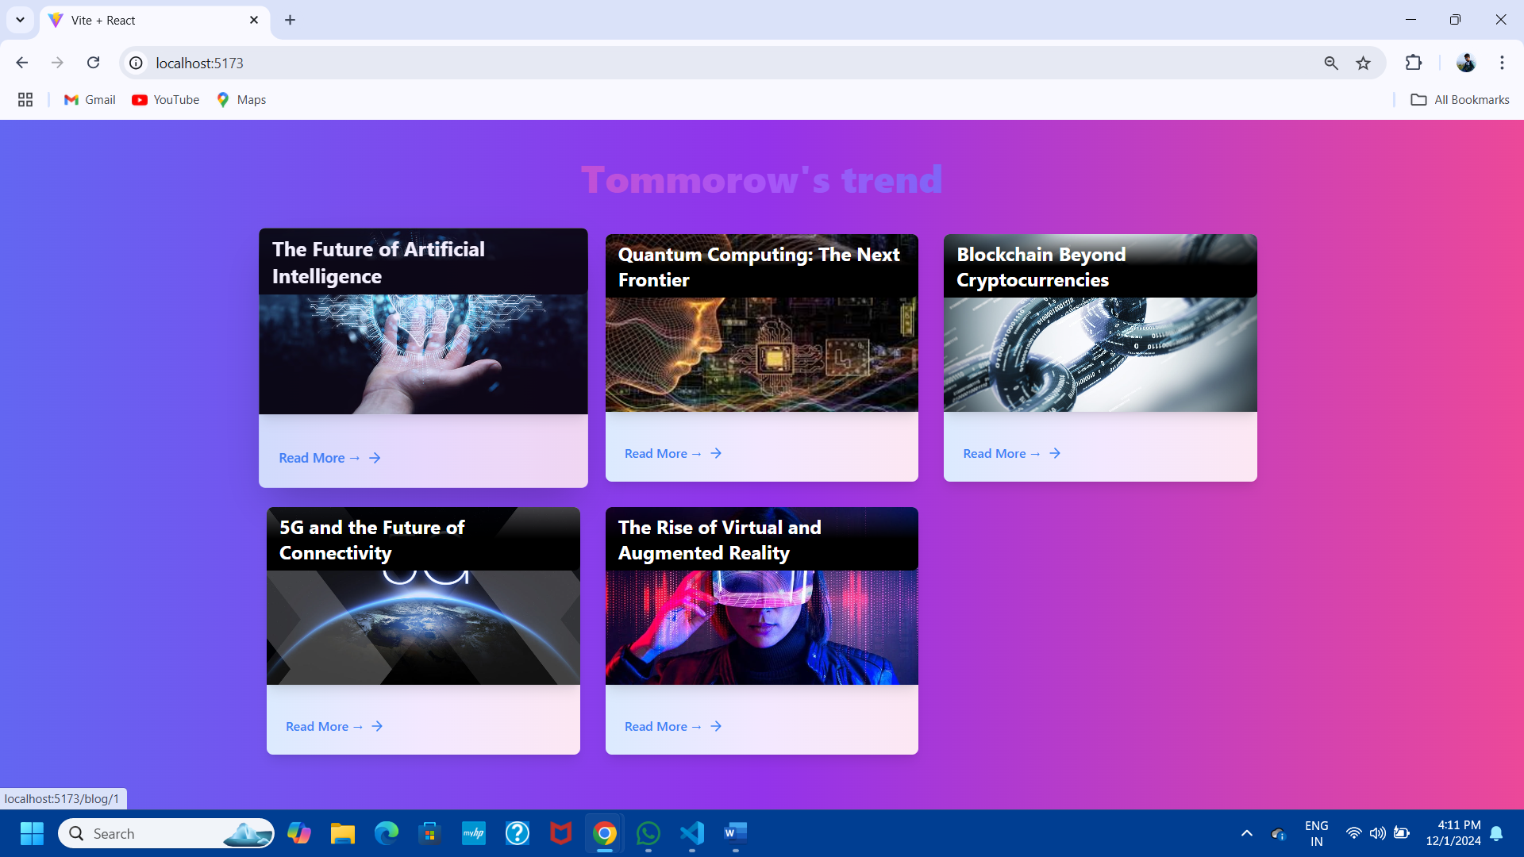

1. **Blog Details Page:**

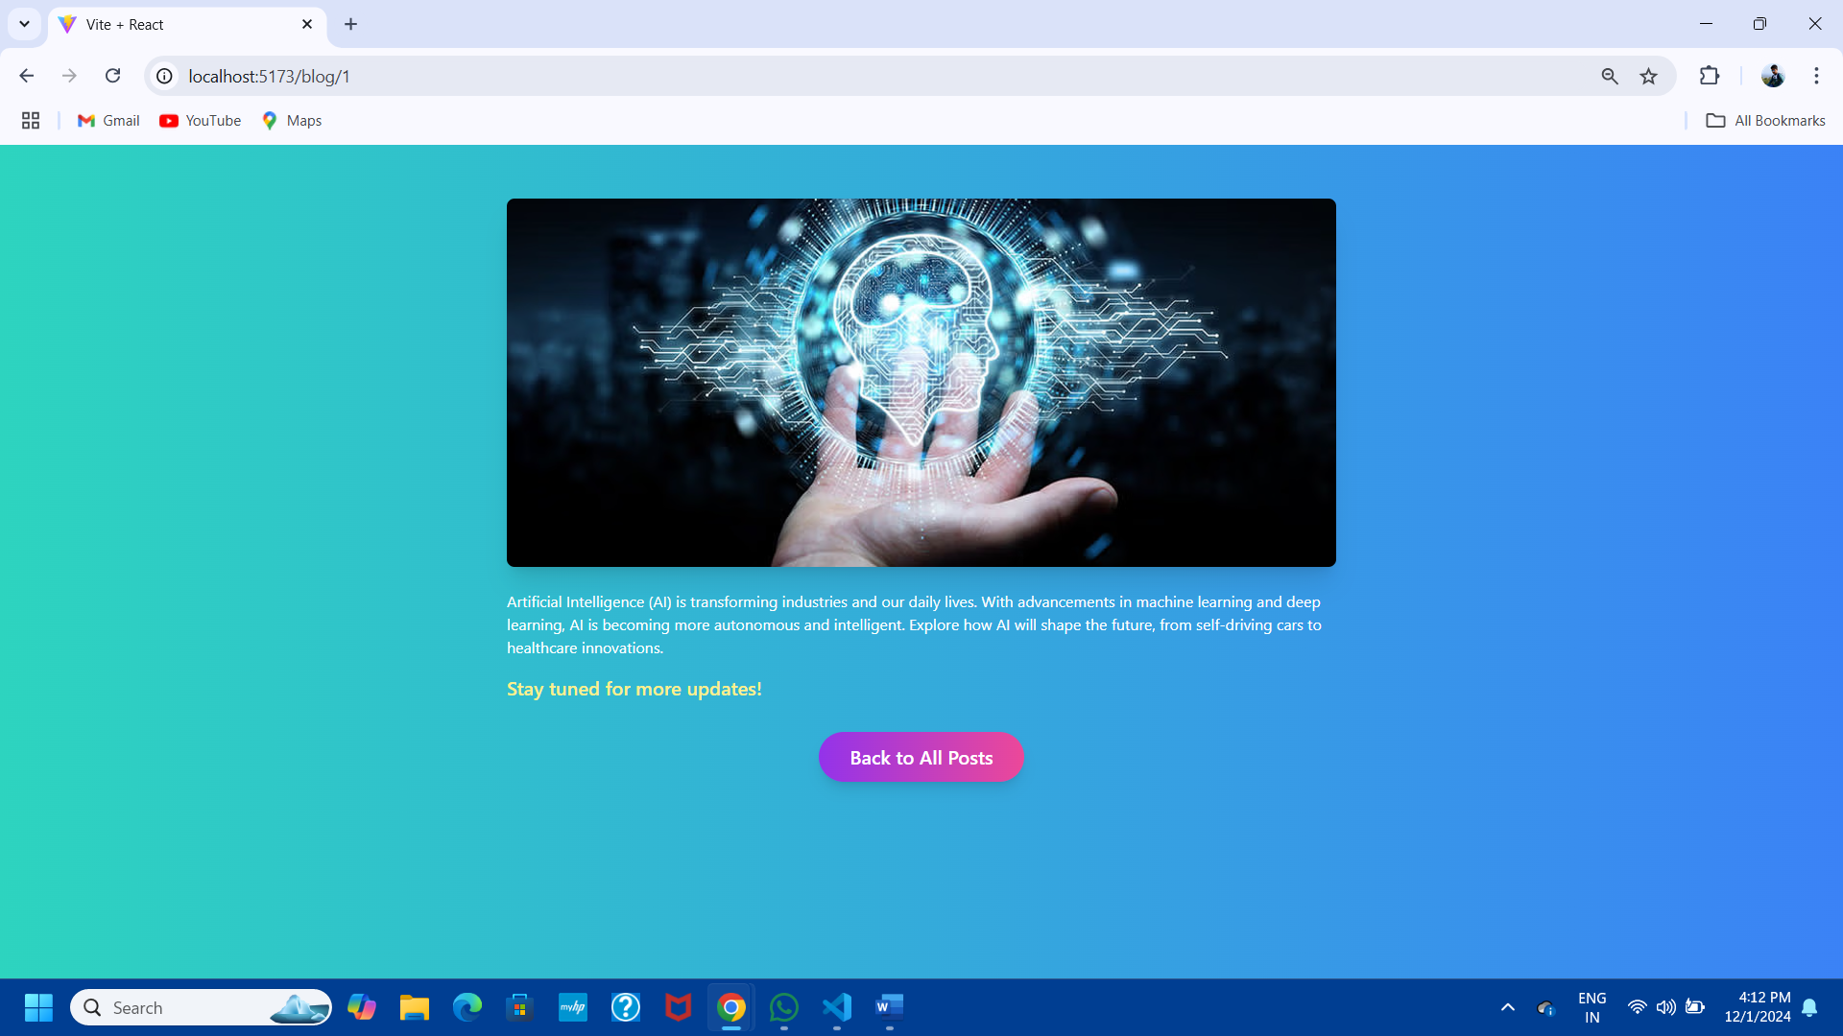

**3. Widget/Algorithm Used in Task:**

* **React Functionalities Used:**
  + **Dynamic Routing with React Router:**
    - Implemented nested and parameterized routes for individual blog pages.
  + **State Management:**
    - Passed blog data using props and used useParams to fetch blog-specific content dynamically.
* **Design with Tailwind CSS:**
  + **Card Design for Blog Previews:**
    - Added hover effects with scale and shadow transitions to make blog cards interactive.
    - Used grid layout for displaying blogs in a responsive manner.
  + **Blog Details Page Design:**
    - Applied background gradients, padding, and rounded corners for an appealing look.
    - Used utility classes to handle typography, spacing, and responsiveness.
* **Features and Enhancements:**
  + Included fallback images for blogs without images.
  + Designed a gradient background for the blog details page to make it visually engaging.